PROJECT 4

REQUIREMENTS:
- Use Azure data factory as an orchestration tool, Databricks as transformation tool and SQL database or Unity Catalog as your gold layer.

- Create a catalog, create schema, then create volume. Fetch your data from GitHub repository using a Notebook. Get the data from these 3 links into your volume. As per data, suitable column names should be given.
https://raw.githubusercontent.com/MicrosoftLearning/mslearn-databricks/main/data/2019.csv
https://raw.githubusercontent.com/MicrosoftLearning/mslearn-databricks/main/data/2020.csv
https://raw.githubusercontent.com/MicrosoftLearning/mslearn-databricks/main/data/2021.csv

- Create an aggregation data based on above file/table columns. Create a pipeline and schedule a pipeline in Data factory to orchestrate the notebook(s).
- Use plotly package from matplotlib module and try to generate a visual.

SOLUTION ARCHITECTURE:
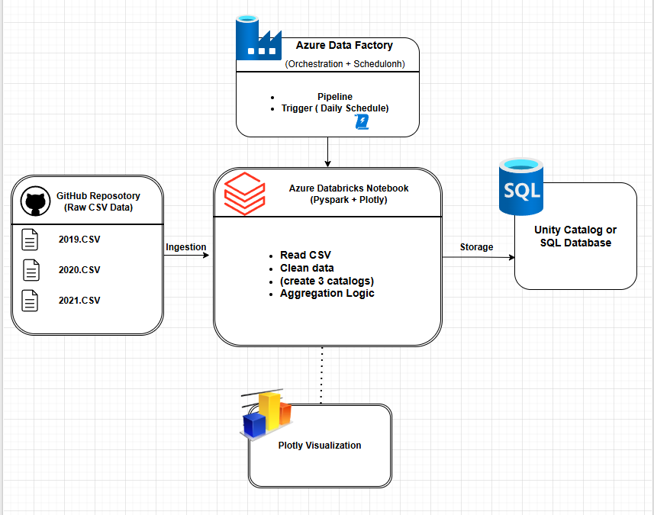
ADF Pipeline:
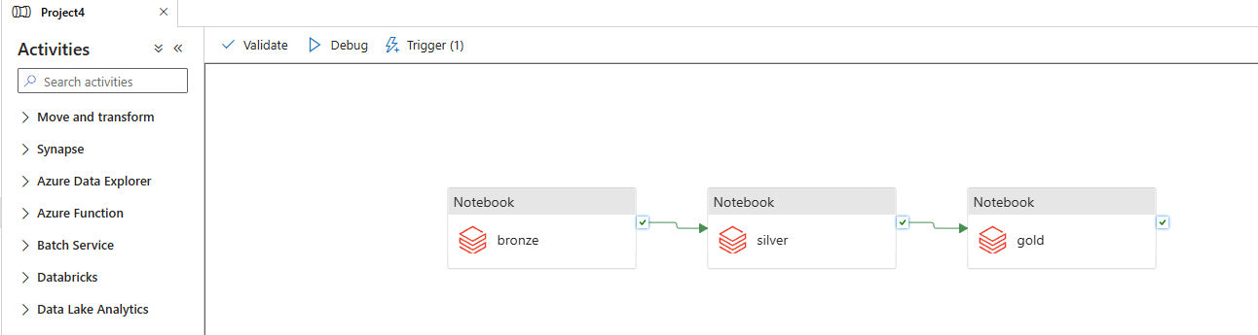

Trigger:
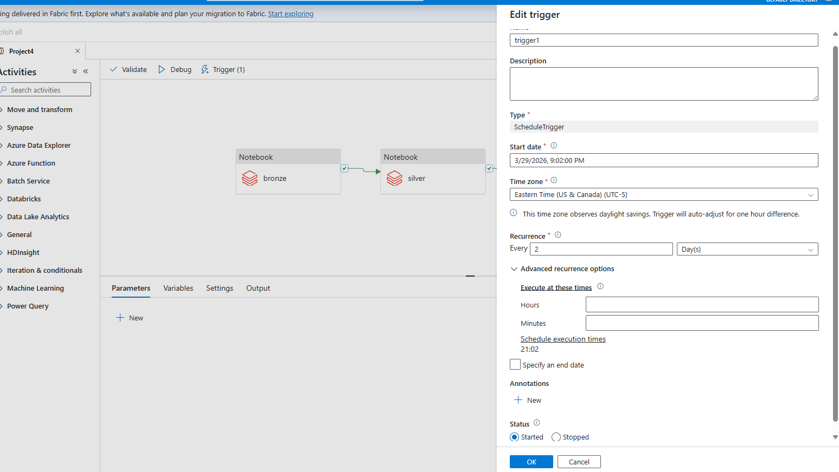

Notebook linking(Access token):
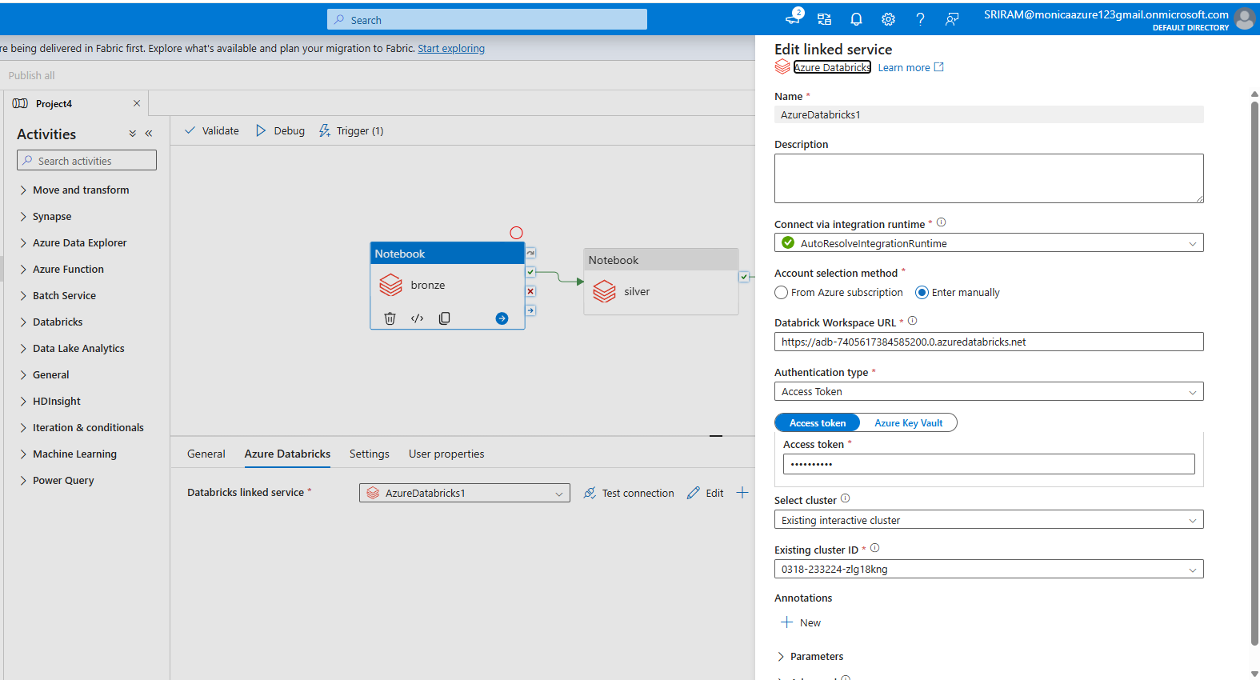
Choose the notebook you want accordingly in settings: (Bronze/Silver/Gold)
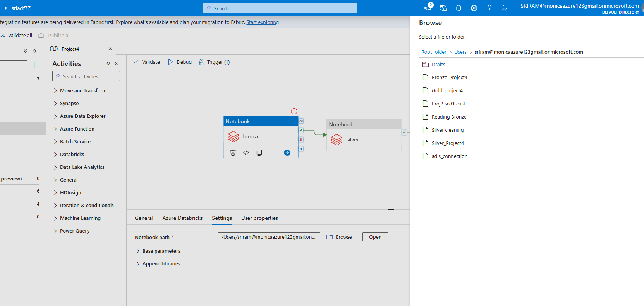

BRONZE NOTEBOOK: (Creation and Ingestion)
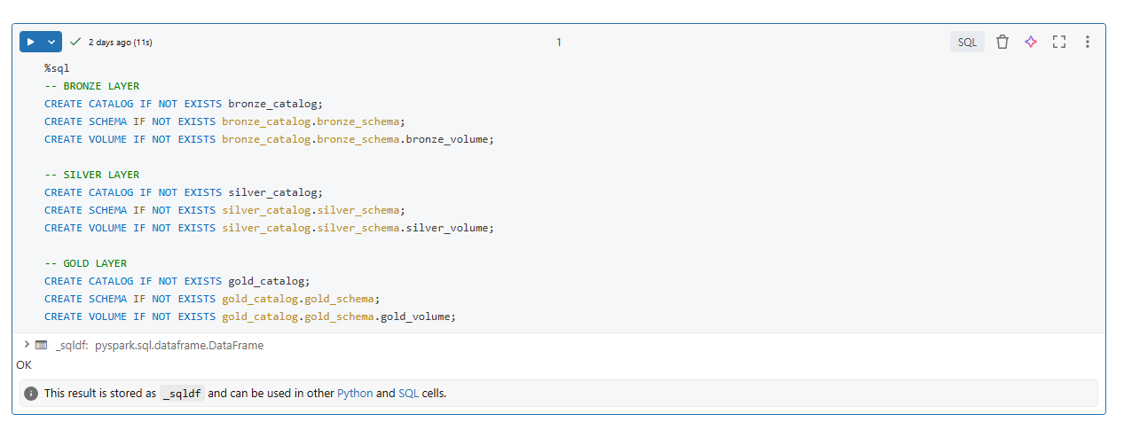
Importing data from GitHub:
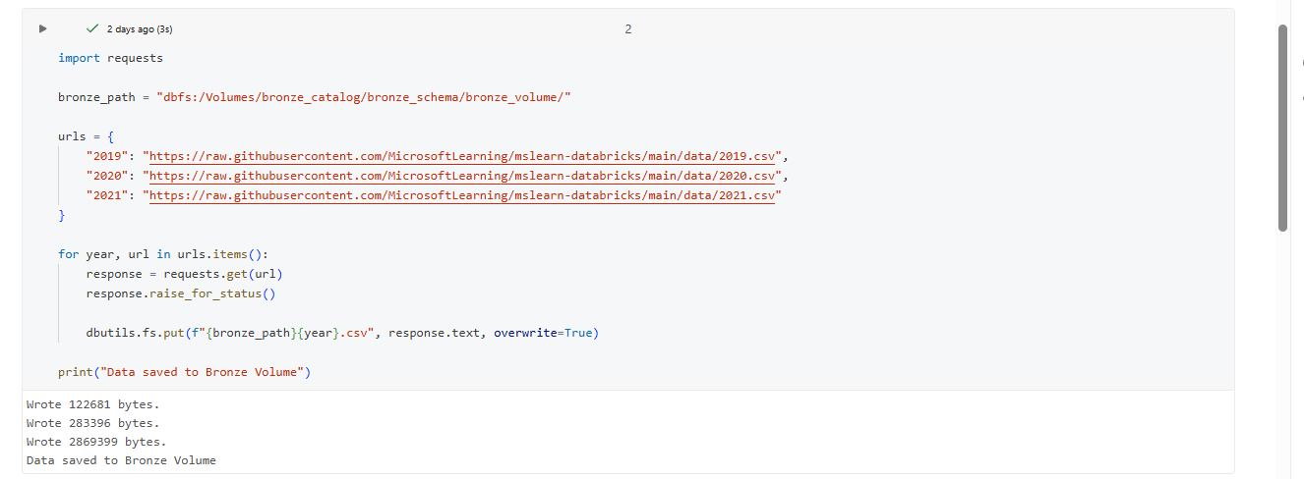
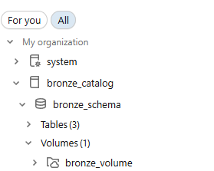
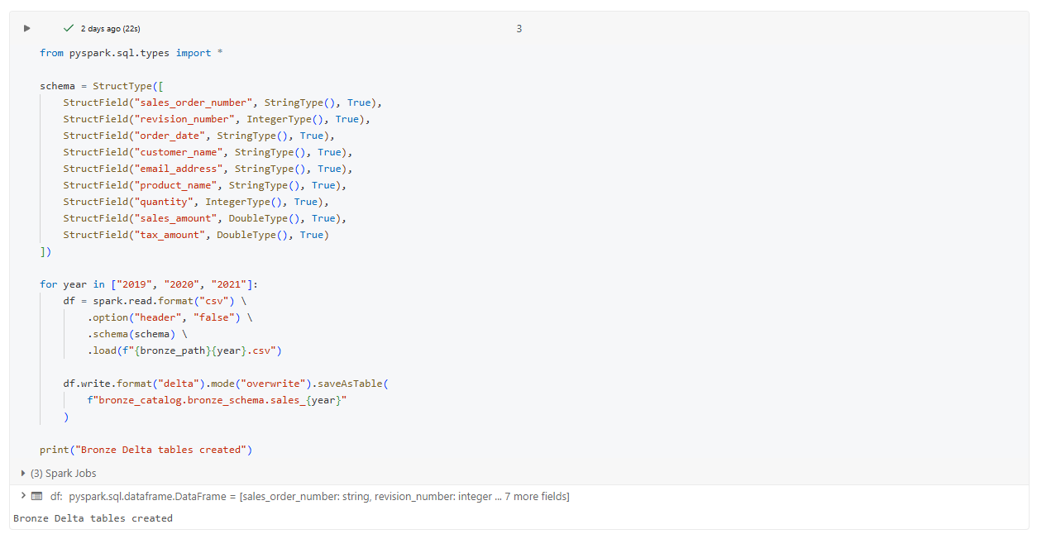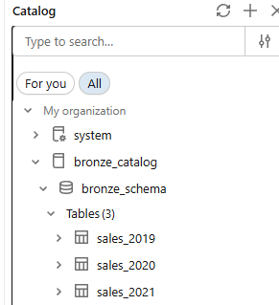

Displaying sample bronze data: 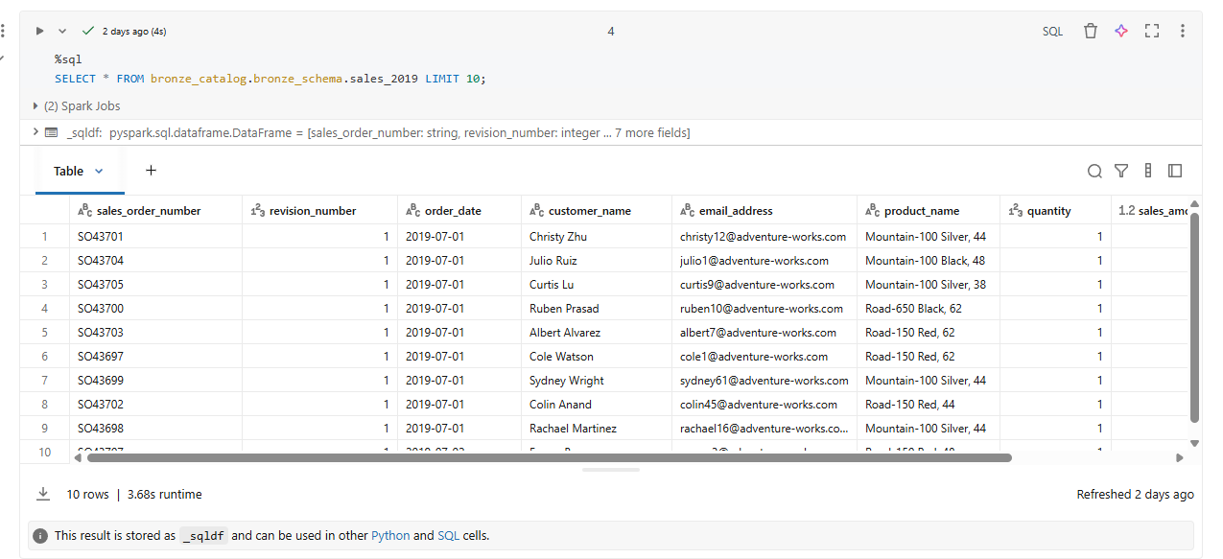

SILVER NOTEBOOK: (Cleaning)
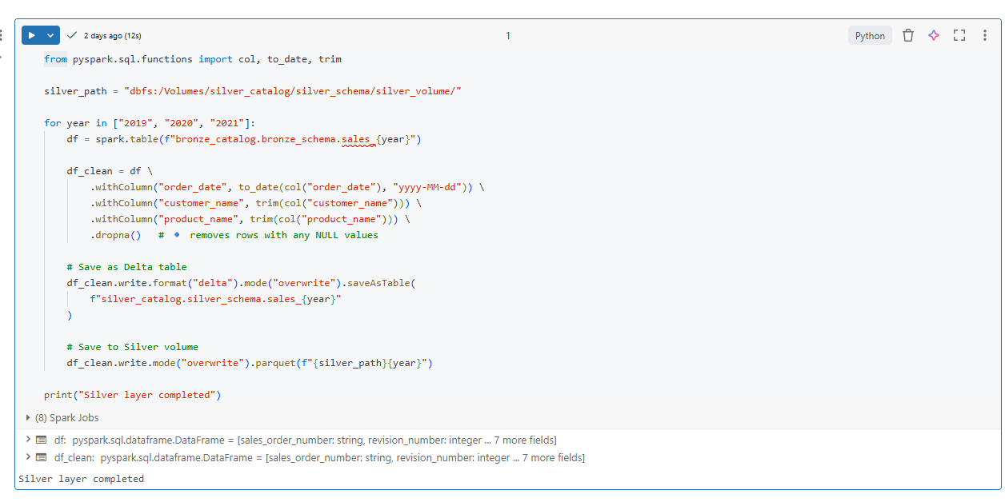
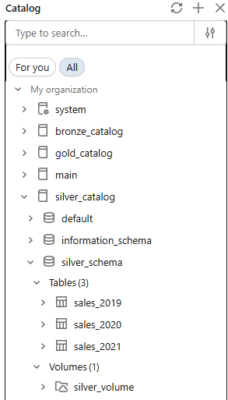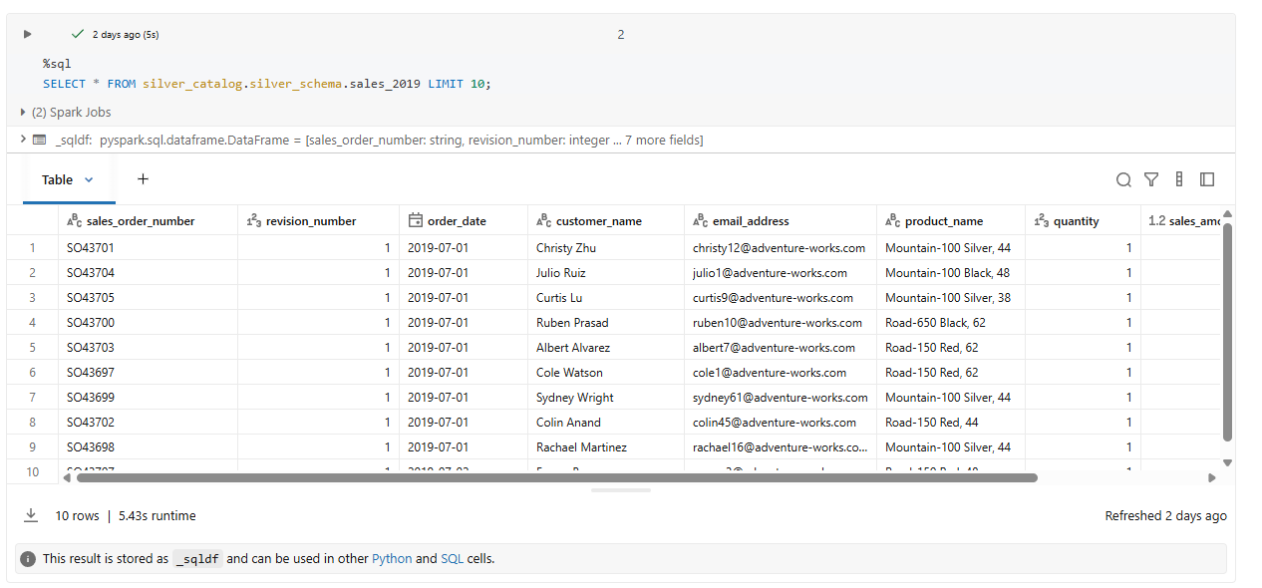

Gold Notebook: (Aggregation and plotly)
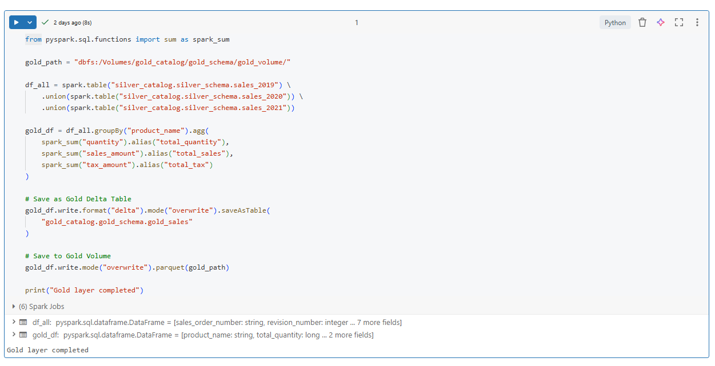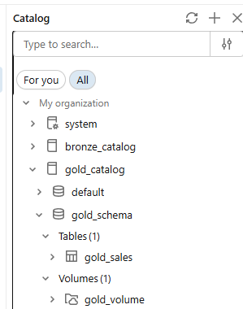
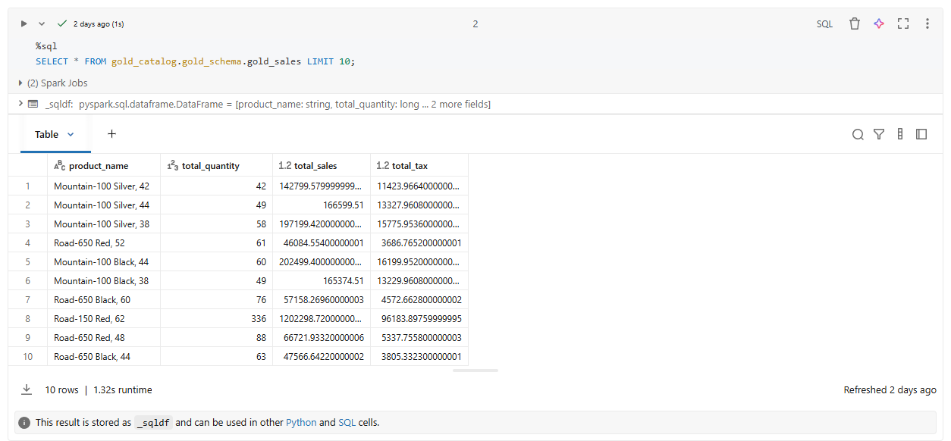

Plotly:
